**B.M.S COLLEGE OF ENGINEERING BENGALURU**

Autonomous Institute, Affiliated to VTU



**AAT**

**22CS1ESPOP**

**“Restaurant Menu with Total Bill”**

*Submitted in partial fulfillment of the requirements for AAT*

Bachelor of Engineering

in

Computer Science and Engineering

*Submitted by:*

Pannaga R Bhat

(1BM22CS189)

Pranav R Hegde

(1BM22CS202)

Department of Computer Science and Engineering

B.M.S College of Engineering

Bull Temple Road, Basavanagudi, Bangalore 560 019

2022-2023

**B.M.S College of EngineerinG**

**DEPARTMENT OF COMPUTER SCIENCE AND ENGINEERING**



***DECLARATION***

We, Pannaga R Bhat (1BM22CS189), Pranav R Hegde (1BM22CS202) students of 2nd Semester, B.E, Department of Computer Science and Engineering, BMS College of Engineering, Bangalore, hereby declare that, this AAT Project entitled “**Restaurant Menu with Total Bill** " has been carried out in Department of CSE, BMS College of Engineering, Bangalore during the academic semester June - August 2023. I also declare that to the best of our knowledge and belief, the AAT Project report is not from part of any other report by any other students.

**Signature of the Candidate**

Pannaga R Bhat (1BM22CS189)

Pranav R Hegde (1BM22CS202)

**BMS College of EngineerinG**

**DEPARTMENT OF COMPUTER SCIENCE AND ENGINEERING**



***CERTIFICATE***

This is to certify that the AAT Project titled “**Restaurant Menu with Total Bill”** has been carried out by Pannaga R Bhat (1BM22CS189),Pranav R Hegde (1BM22CS202)during the academic year 2022-2023.

Signature of the Faculty in Charge

Table of Contents

|  |  |  |
| --- | --- | --- |
| Sl. No | Title | Page no |
| 1 | Introduction | 5 |
| 1.1 | Problem Definition | 5 |
| 1.2 | Scope | 5 |
| 1.3 | Motivation | 5 |
| 1.4 | Abstract | 6 |
| 2 | Hardware and Software requirement | 6 |
| 3 | Design | 7 |
| 3.1 | Project Flow | 7 |
| 3.2 | Algorithm | 8-11 |
| 4 | Implementation | 12 |
| 4.1 | Source code | 12-25 |
| 4.2 | Experimental Analysis and Results | 25-33 |
| 5 | Conclusion | 34 |
| 6 | References | 34 |

1 INTRODUCTION

The provided C program is user friendly code is desgnied to streamline your dining experience ,making it effortless for both customers and staff. With our intuitive interface, customers can easily browse through our menu .As customers explore the menu the program tracks the selections, allowing to customize their order. Once you are ready with all the orders program will generate detailed bill, ensuring transparecy and accuracy.

* 1. PROBLEM DEFINITION

Menu: Menu presentation and display may not be satifactory according to customers

We can also provide images of each items in menu

Order management: Management of many orders at a time may be not easy human job at limited time.

Bill: Item based bill to customers so that they re-view before they make payment

* 1. SCOPE

For Dine-In option Hotel menu and bill management system will cover selecting items, customized order, managing order in time, calculation of bills and payments. This may not be applicable for online order and delivery

* 1. MOTIVATION

Accuracy and Efficient:Automated Billing and Ordering System reduces human errors

Customization:Digital menu and billing system is easy to customize like after feedback and suggestions

Customer experience:User friendly system

Reduced Paper usage:As our country is towards cashless transactions,we try to reduce use of paper on bill and menu cards

Some motivations on our point of view

1.4 ABSTRACT

The Program that stimulates the ordering and generates a bill .

Program is designed to provide user friendly for customers.

Some of the Features:

Menu Selection: Program presents a menu with multiple categories such as breakfast , hot beverages with snacks , special dosas , meals ,starters, chats and many more.

Quantity and Pricing: for each item selected ,user is asked to enter the quantity based on which pricing is made and confirmed.

Itemized bill: Program maintains a list of selected items with no of quantity of each including quantity of them.Detailed bill will be presented to customers which is in the understandable format

Gst Calculation:Program calculates the Total bill after suming up the subtotal of all multiple categories.Later 18% gst is applied and computes the final bill, assuring no mistakes or doing any kind of delay in the service.

2 HARDWARE AND SOFTWARE REQUIREMENT

Hardware Requirements:

• Personal Computer or Laptop

• Keyboard and Mouse

Software Requirements:

• Operating System: Windows, macOS, or Linux

• Code Editor/IDE: Any C compiler, e.g., GCC, Visual Studio, Code::Blocks, etc.

3DESIGN**:**

The program follows a simple design and flow.

Program stars with declaring all neccessary variables.

Program just demands numbers from customers for which the dish is allotted.

Conditional statements (if-else)are used.

Switch function is used in selection of main type in menu.

3.1 PROJECT FLOW:

Initialization: Initialize variables for quantities, amounts, choices, and strings.

Initialize arrays to store selected items, quantities, and amounts.

Display Welcome Message and Main Loop: Display a welcome message to the user.

Enter a loop for the main menu options.

Main Menu: Display menu categories and options.

Prompt the user to input their choice.

Category Selection: Depending on the user's choice, display items within the selected category.

Prompt the user to enter 'B' to confirm selection or return to the main menu.

Item Selection Loop: Enter a loop to select items and quantities within the chosen category.

Display available items and their prices.

Prompt the user to input the item number and quantity desired.

Calculate the subtotal for the selected item and quantity.

Store the selected item's description, quantity, price, and subtotal in arrays.

Continue Ordering: After each item selection, ask the user if they want to place more orders.

If yes, continue to the next iteration; otherwise, exit the loop.

Generate Bill: Display the selected items, quantities, prices, and subtotals in an itemized format.

Calculate Total: Calculate the total bill amount by summing the subtotals of all selected items.

Apply GST: Calculate the Goods and Services Tax (GST) at 18% of the total bill amount.

Display Final Bill: Display the final bill, including item details, subtotal, GST, and total amount.

Thank You Message: Display a thank you message for visiting the restaurant.

Program Ends: Display a program end message.

Terminate the program.

3.2 ALGORITHM:

Algorithm: Shree Guru Sagar Hotel Ordering System

Variables:

Initialize vstr, tvstr = 0, vfd, tvfd = 0, fd, tfd = 0, d, amt = 0, tamt = 0, choice, incr = 0, i = 0, tot, total_amount, str[3], choice1 = 1

Initialize itemchosen[100][150], amount[50], Q[50]

Initialize tamt1 to tamt13

Display "Welcome to SHREE GURU SAGAR"

While choice1 is true:

Display Menu:

Display "Enter for Breakfast: 1"

Display "Enter for Hot Beverages with snacks: 2"

Display "Enter for Special Dosas's: 3"

Display "Enter for Meals: 4"

...

Display "Enter for Desserts Scoops: 14"

Display "Enter your choice"

Input choice

Switch choice:

Case 1:

Display "Welcome to Breakfast!!!:"

Display "Enter 'B' for Breakfast"

Input str

If str is equal to "B":

Display Breakfast Menu with Prices

Set choice to 1

While choice is true:

Display "Choose the Breakfast by choosing number:"

Display "Enter 0 to stop"

Input vstr

If vstr is greater than 8:

Display "Item number that was selected is not present, please select the correct choice"

Continue to next iteration of loop

If vstr is equal to 0:

Break the loop

Concatenate itemchosen[incr] with selected item description

Input tvstr

Calculate amt based on vstr and tvstr

Convert amt and tvstr to strings and concatenate to itemchosen[incr]

Increment incr

Add amt to tamt

Display "Do you want to place more order? Enter 1 to order / Enter 0 to stop"

Input choice

Default:

Display "Please select correct choice"

Display "Enter 1 to go Main Menu or Enter 0 to get the bill"

Input choice1

Display "GURU SAGAR HOTEL - ITEM SELECTED"

Display "Item \t\tQuan Price\tTotal"

For i from 0 to incr - 1:

Display itemchosen[i]

Calculate total amount with GST

Display total_amount

Display "Thanks for visiting GURU SAGAR HOTEL"

Display "Your Pleasure Our Comfort!!!!"

Display "Visit Again!!!!!"

Display "Program Ends"

End Algorithm

4 IMPLEMENTATION:

As of my last knowledge update in September 2021, smart menu systems were being implemented in various hotels around the world, especially in response to the COVID-19 pandemic, which increased the demand for touchless and digital solutions. These smart menu systems typically involve using QR codes that guests can scan with their smartphones to access digital menus, reducing the need for physical menus and promoting a contactless dining experience.

However, the implementation of smart menu systems can vary greatly from one hotel to another, and new developments may have occurred since then. The extent to which these systems are implemented can depend on factors such as the hotel's size, budget, technological infrastructure, and customer preferences

4.1 SOURCE CODE:

#include<stdio.h>

#include<string.h>

#include<math.h>

void main()

{

int vstr,tvstr=0,vfd,tvfd=0,fd,tfd=0,d; //Variables for quantity

int amt=0,tamt=0,tamt1=0,tamt2=0,tamt3=0,tamt4=0,tamt5=0,tamt6=0,tamt7=0,tamt8=0,tamt9=0,tamt10=0,tamt11=0,tamt12=0,tamt13=0;

int ch, incr=0,i=0;

float tot,total_amount;

char itemchosen[100][150];

char amount[50];

char Q[50];

char str[3];

int choice;

int choice1=1;

printf("Welcome to SHREE GURU SAGAR\n\n");

while(choice1) //MENU LIST

{

printf("Enter for Breakfast: 1\n");

printf("Enter for Hot Drinks with snacks: 2\n");

printf("Enter for Special Dosas's: 3\n");

printf("Enter for Meals:4\n");

printf("Enter for Starter corner: 5\n");

printf("Enter for Chats: 6\n");

printf("Enter for Soups: 7\n");

printf("Enter for Kabab Corner: 8\n");

printf("Enter for Kofta: 9\n");

printf("Enter for Tandoor Khajana: 10\n");

printf("Enter for Subzi Bahar:11\n");

printf("Enter for Rice And Noodles: 12\n");

printf("Enter for Milk Shake: 13\n");

printf("Enter for Desserts Scoops: 14\n");

printf("Enter your choice\n");

scanf("%d",&ch);

switch(ch)

{

case 1: //BREAKFAST

{

char c[8][15] = {"Idly Sambar","Vada\t","Khara Bath","Kesari Bath","Chow Chow Bath","Poori Saagu", "Akki Rotti", "Rava Idly" };

printf("Welcome to Breakfast!!!:\n");

printf("Enter 'B' for BreakFast\n");

scanf("%s",&str);

if(strcmpi(str,"B")==0)

{

printf("Breakfast\t\t\tPrice in Rs.\n");

printf("1.Idly Sambar\t\t\t50\n");

printf("2.Vada\t\t\t\t50\n");

printf("3.Khara Bath\t\t\t50\n");

printf("4.Kesari Bath\t\t\t50\n");

printf("5.Chow Chow Bath\t\t55\n");

printf("6.Poori Saagu\t\t\t80\n");

printf("7.Akki Rotti\t\t\t60\n");

printf("8.Rava Idly with chatni\t\t65\n");

choice=1;

while(choice)

{

printf("Choose the Breakfast by choosing number:");

printf("\tEnter 0 to stop\n");

scanf("%d",&vstr);

if(vstr>8)

{

printf("Item number that was selected is not present, please select the correct choice\n");

continue;

}

if(vstr==0)

{

break;

}

strcat(itemchosen[incr],c[vstr-1]);

printf("Enter the Quantity\n");

scanf("%d",&tvstr);

if(vstr>=1&&vstr<=4)

{

amt=tvstr*50;

sprintf(amount, "%d", amt);

sprintf(Q,"%d", tvstr); // int to string

strcat(itemchosen[incr],"\t");

strcat(itemchosen[incr],Q);

strcat(itemchosen[incr],"\t50\t");

strcat(itemchosen[incr++],amount); //incre++ because after storing 1st item incr becomes 1 to store next selected item

}

if(vstr==5)

{

amt=tvstr*55;

sprintf(amount, "%d", amt);

sprintf(Q, "%d", tvstr); // int to string

strcat(itemchosen[incr],"\t");

strcat(itemchosen[incr],Q);

strcat(itemchosen[incr],"\t55\t");

strcat(itemchosen[incr++],amount);

}

if(vstr==6)

{

amt=tvstr*80;

sprintf(amount, "%d", amt);

sprintf(Q, "%d", tvstr); // int to string

strcat(itemchosen[incr],"\t");

strcat(itemchosen[incr],Q);

strcat(itemchosen[incr],"\t80\t");

strcat(itemchosen[incr++],amount);

}

if(vstr==7)

{

amt=tvstr*60;

sprintf(amount, "%d", amt);

sprintf(Q, "%d", tvstr); // int to string

strcat(itemchosen[incr],"\t");

strcat(itemchosen[incr],Q);

strcat(itemchosen[incr],"\t60\t");

strcat(itemchosen[incr++],amount);

}

if(vstr==8)

{

amt=tvstr*65;

sprintf(amount, "%d", amt);

sprintf(Q, "%d", tvstr); // int to string

strcat(itemchosen[incr],"\t");

strcat(itemchosen[incr],Q);

strcat(itemchosen[incr],"\t65\t");

strcat(itemchosen[incr++],amount);

}

tamt=tamt+amt;

printf("Do you want to place more order?\tEnter 1 to order/Enter 0 to stop\n");

scanf("%d",&choice);

}

}

}

break;

case 2:

{

printf("Enter 'HD' for Hot Drinks with snacks!!!\n");

scanf("%s",&str);

char c[10][20] = { "Coffee\t","Tea\t","Bournvita","Horlicks","Badam Milk","Boost\t","Onion Bajji","Capsicum Bajji","Aloo Bajji","Mixed Bajji"};

if(strcmpi(str,"HD")==0)

{

printf("Welcome to Hot Drinks with snacks\n");

printf("Hot Drinks with snacks\t\t\t\tPrice in Rs\n");

printf("1.Coffee\t\t\t\t\t30\n");

printf("2.Tea\t\t\t\t\t\t30\n");

printf("3.Bournvita\t\t\t\t\t60\n");

printf("4.Horlicks\t\t\t\t\t60\n");

printf("5.Badam Milk\t\t\t\t\t80\n");

printf("6.Boost\t\t\t\t\t\t60\n");

printf("7.Onion Bajji\t\t\t\t\t70\n");

printf("8.Capsicum Bajji\t\t\t\t70\n");

printf("9.Aloo Bajji\t\t\t\t\t70\n");

printf("10.Mixed Bajji\t\t\t\t\t70\n");

choice=1;

while(choice)

{

printf("Choose the order by entering Number:");

printf("\tEnter 0 to stop\n");

scanf("%d",&vfd);

if(vfd>10)

{

printf("Item number that was selected is not present, please select the correct choice\n");

continue;

}

if(vfd==0)

{

break;

}

strcat(itemchosen[incr],c[vfd-1]);

printf("Enter the Quantity\n");

scanf("%d",&tvfd);

if(vfd==1||vfd==2)

{

amt=tvfd*30;

sprintf(amount, "%d", amt);

sprintf(Q, "%d", tvfd); // int to string

strcat(itemchosen[incr],"\t");

strcat(itemchosen[incr],Q);

strcat(itemchosen[incr],"\t30\t");

strcat(itemchosen[incr++],amount);

}

if(vfd==7||vfd==8||vfd==9||vfd==10)

{

amt=tvfd*70;

sprintf(amount, "%d", amt);

sprintf(Q, "%d", tvfd); // int to string

strcat(itemchosen[incr],"\t");

strcat(itemchosen[incr],Q);

strcat(itemchosen[incr],"\t70\t");

strcat(itemchosen[incr++],amount);

}

if(vfd==3||vfd==4||vfd==6)

{

amt=tvfd*60;

sprintf(amount, "%d", amt);

sprintf(Q, "%d", tvfd); // int to string

strcat(itemchosen[incr],"\t");

strcat(itemchosen[incr],Q);

strcat(itemchosen[incr],"\t60\t");

strcat(itemchosen[incr++],amount);

}

if(vfd==5)

{

amt=tvfd*80;

sprintf(amount, "%d", amt);

sprintf(Q, "%d", tvfd); // int to string

strcat(itemchosen[incr],"\t");

strcat(itemchosen[incr],Q);

strcat(itemchosen[incr],"\t80\t");

strcat(itemchosen[incr++],amount);

}

tamt1=tamt1+amt;

printf("Do you want to place more order?\tEnter 1 to order/Enter 0 to stop\n");

scanf("%d",&choice);

}

}

}

break;

case 3:

{

char c[11][16]={"Masala Dosa","Butter M D","Set M D\t","Butter Plain D","Set Dosa","Plain Dosa","Kali Dosa","Paper M D","Paper Plain D","Rava Onion D","Tomato Dosa"};

printf("Special Dosa's\t\t\t\tPrice in Rs.\n");

printf("1.Masala Dosa\t\t\t\t70\n");

printf("2.Butter Masala Dosa\t\t\t80\n");

printf("3.Set Masala Dosa\t\t\t80\n");

printf("4.Butter Plain Dosa\t\t\t80\n");

printf("5.Set Dosa\t\t\t\t70\n");

printf("6.Plain Dosa\t\t\t\t90\n");

printf("7.kali Dosa\t\t\t\t90\n");

printf("8.Paper Masala Dosa\t\t\t80\n");

printf("9.Paper Plain Dosa\t\t\t80\n");

printf("10.Rava Onion Dosa\t\t\t90\n");

printf("11.Tomato Dosa\t\t\t\t90\n");

choice=1;

while(choice)

{

printf("Choose your Dosa by entering your number!!");

printf("\tEnter 0 to stop\n");

scanf("%d",&d);

if(d>11)

{

printf("Item number that was selected is not present, please select the correct choice\n");

continue;

}

if(d==0)

{

break;

}

strcat(itemchosen[incr],c[d-1]);

printf("Enter the Quantity\n");

scanf("%d",&tvfd);

if(d==1||d==5)

{

amt=tvfd*70;

sprintf(amount, "%d", amt);

sprintf(Q, "%d", tvfd); // int to string

strcat(itemchosen[incr],"\t");

strcat(itemchosen[incr],Q);

strcat(itemchosen[incr],"\t70\t");

strcat(itemchosen[incr++],amount);

}

if(d==2||d==3||d==4||d==8||d==9)

{

amt=tvfd*80;

sprintf(amount, "%d", amt);

sprintf(Q, "%d", tvfd); // int to string

strcat(itemchosen[incr],"\t");

strcat(itemchosen[incr],Q);

strcat(itemchosen[incr],"\t80\t");

strcat(itemchosen[incr++],amount);

}

if(d==6||d==7||d==10||d==11)

{

amt=tvfd*90;

sprintf(amount, "%d", amt);

sprintf(Q, "%d", tvfd); // int to string

strcat(itemchosen[incr],"\t");

strcat(itemchosen[incr],Q);

strcat(itemchosen[incr],"\t90\t");

strcat(itemchosen[incr++],amount);

}

tamt2=tamt2+amt;

printf("Do you want to place more order?\tEnter 1 to order/Enter 0 to stop\n");

scanf("%d",&choice);

}

}

break;

case 4:

{

char c[2][14]={"SouthIndMeals","NorthIndMeals"}; // Two values in [1st] of many length[2nd]

printf("Meals\t\t\t\t\tPrice in Rs.\n");

printf("1.South Indian Meals\t\t\t60\n");

printf("2.North Indian Meals\t\t\t100\n");

choice=1;

while(choice)

{

printf("Choose your Meals by entering your number!!\n");

scanf("%d",&d);

if(d>2)

{

printf("Item number that was selected is not present, please select the correct choice\n");

continue;

}

if(d==0)

{

break;

}

strcat(itemchosen[incr],c[d-1]);

printf("Enter the Quantity\n");

scanf("%d",&tvfd);

if(d==1)

{

amt=tvfd*60;

sprintf(amount, "%d", amt);

sprintf(Q, "%d", tvfd); // int to string

strcat(itemchosen[incr],"\t");

strcat(itemchosen[incr],Q);

strcat(itemchosen[incr],"\t60\t");

strcat(itemchosen[incr++],amount);

}

if(d==2)

{

amt=tvfd*100;

sprintf(amount, "%d", amt);

sprintf(Q, "%d", tvfd); // int to string

strcat(itemchosen[incr],"\t");

strcat(itemchosen[incr],Q);

strcat(itemchosen[incr],"\t100\t");

strcat(itemchosen[incr++],amount);

}

tamt3=tamt3+amt;

printf("Do you want to place more order?\tEnter 1 to order/Enter 0 to stop\n");

scanf("%d",&choice);

}

}

break;

break;

default:

printf("Please select correct choice!!.\n");

}

printf("Enter 1 to go Main Menu or Enter 0 to get the bill\n");

scanf("%d",&choice1);

}

printf("\n\n\n********GURU SAGAR HOTEL********\n");

printf("**********ITEM SELECTED*********\n");

printf("Item \t\tQuan Price\tTotal\n");

while (i < incr)

{

printf("%s\n",itemchosen[i]); //to print selected items in the bill.

i++;

}

tot=tamt+tamt1+tamt2+tamt3+tamt4+tamt5+tamt6+tamt7+tamt8+tamt9+tamt10+tamt11+tamt12+tamt13;

float gst=tot+(tot*18/100);

total_amount=roundf(gst);

printf("Total Amount=%f\n",tot);

printf("The total amount with GST is %f",gst);

printf("\nTotal Amount to be paid=%f",total_amount);

printf("\nThanks for visiting GURU SAGAR HOTEL");

printf("\nYour Pleasure Our Comfort!!!!");

printf("\nVisit Again!!!!!");

printf("\n******Program Ends******");

}

4.2 EXPERIMENTAL ANALYSIS AND RESULTS

1) Here are some of the output .We have showed full menu using 15 images.

Even operation of program is displayed.

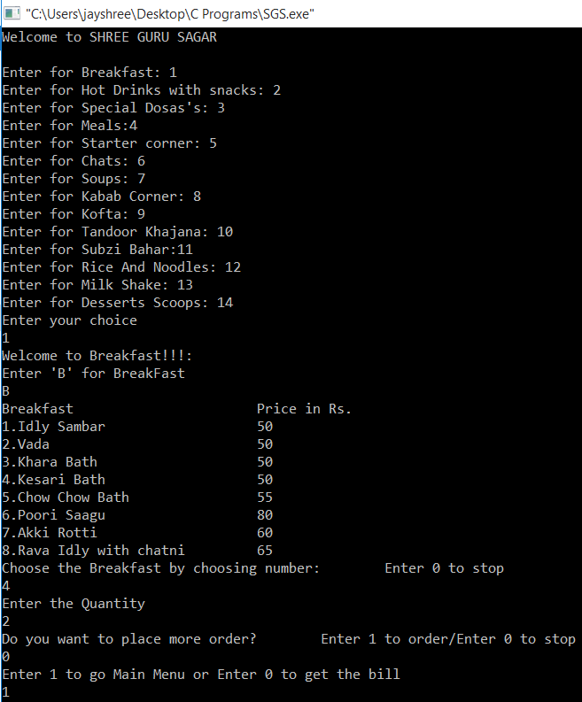

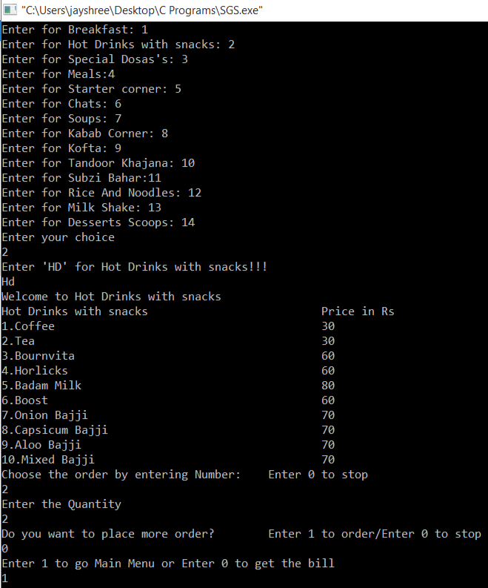

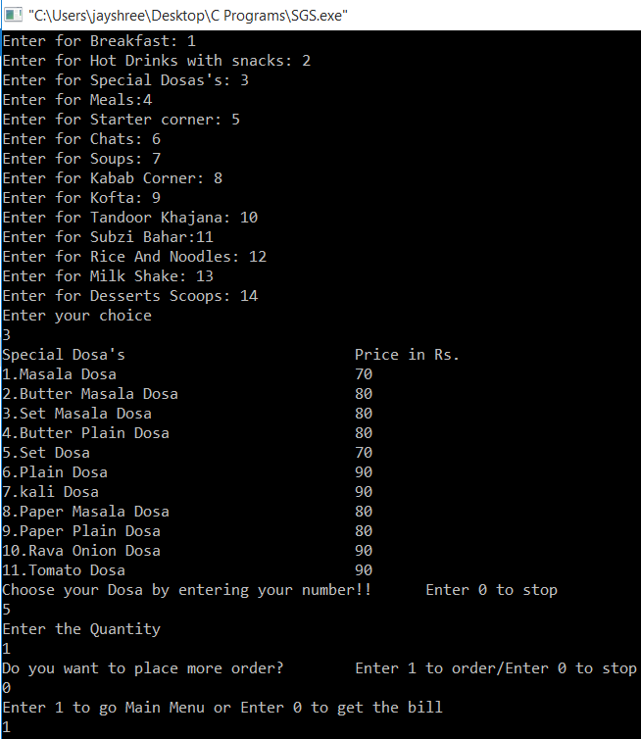

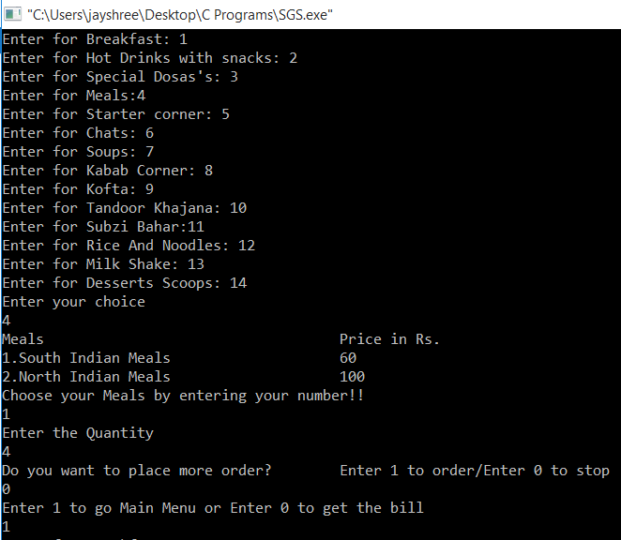

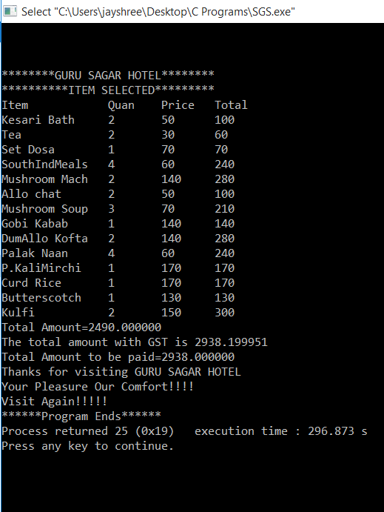

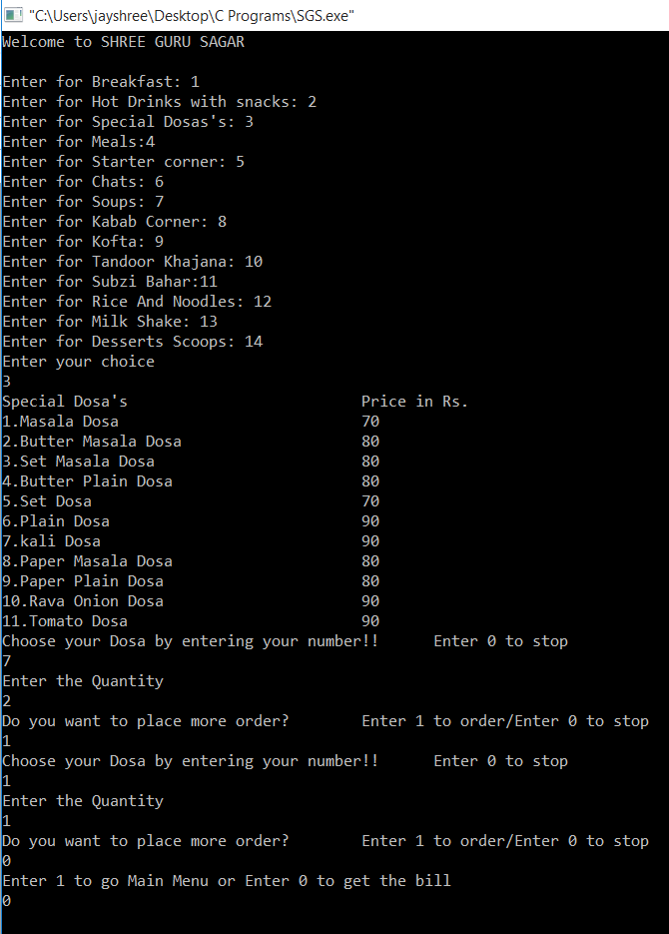

2) In this above output we are ordering food under same category

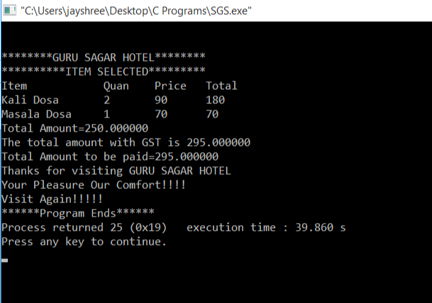

Bill of the repeating order under same category(ie.Dosa)

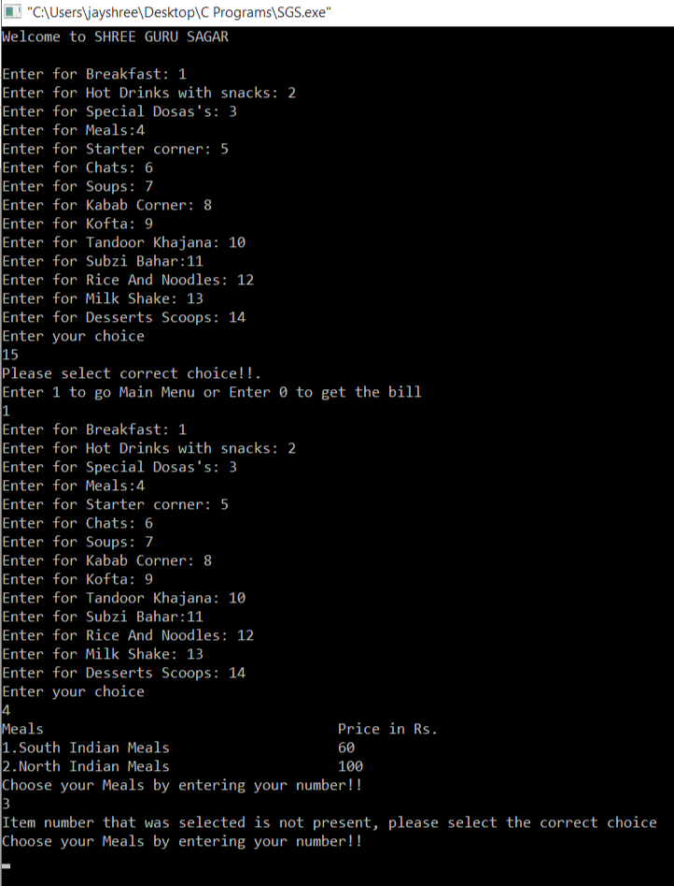

This is an example of a possible error in the program which is solved by displaying user friendly message.

5. CONCLUSION

Interactive Interface: The program boasts an intuitive and interactive user interface, enabling customers to easily browse through menu categories, make selections, and specify quantities.

Accurate Calculations: Precise calculations ensure that the subtotal for each selected item is accurately determined based on the chosen quantity. The program also applies an appropriate Goods and Services Tax (GST) rate to the total bill, ensuring accurate taxation.

Itemized Bill Generation: Customers receive a comprehensive and well-organized itemized bill that lists their selected items, quantities, individual prices, and subtotals. This transparency allows customers to review their orders and costs.

Convenient Ordering: The program simplifies the ordering process by providing the option to place additional orders after each selection. This feature enhances flexibility and convenience for customers who may wish to explore a diverse range of menu items.

Customer Appreciation: The program concludes with a heartfelt thank you message, expressing gratitude to customers for their visit and conveying the restaurant's commitment to providing a pleasurable dining experience.

6. REFERENCES:

1. C Programming Language Documentation - <https://en.cppreference.com/w/c>

2. GCC Compiler - <https://gcc.gnu.org/>

3. Visual Studio IDE - <https://visualstudio.microsoft.com/>

4. Code::Blocks IDE - <http://www.codeblocks.org/>